Cinturon360
Engineering, Infrastructure, and Platform Budget
12-Month Execution Plan

Detailed Use of Funds, Infrastructure Strategy, and Execution Plan
Prepared for Investor Review

Funding Allocation: AUD $760,000
Coverage Period: 12 months

Prepared by:
Danijel Wynyard
Lead Architect and Platform Owner
Cinturon360

Table of Contents
Scope 4
Budget Summary (Baseline vs Buffer) 4
Totals 4
Line-Item Totals (high level) 5
Staffing 5
Lead Architect (Australia, NSW) 5
Role Coverage 5
Buffer rationale 6
India Engineering Team (Direct hires) 6
Team Model (4 engineers) 6
Engagement Model 6
Quality Controls (how we ensure “on par with AU”) 6
Included in Baseline 6
Buffer Rationale 6
Hardware & Workstations 7
Included equipment (per engineer) 7
Operational approach 7
Buffer rationale 7
Infrastructure 7
Why 3 environment are non-negotiable 8
Production (Azure) 8
Compute 8
Data 8
Storage 8
Security 8
Observability 9
Cost drivers / variance sources 9
Buffer rationale 9
UAT (Azure) 9
DEV (Hetzner) 10
Shared Monitoring/Logging/Backup 10
Infrastructure totals 11
Software Licensing & Tooling 11
Tooling Categories 11
Platform Integrations & External Services 12
What this bucket is for 12
Legal, Accounting & Compliance 12
Operational Contingency Reserve 13
Burn Rate & Runway (Chart + Tables) 13
Baseline Monthly Burn Table 13
Burn Chart 14
Cash Remaining Chart 15
Investor-Relevant Section 15
Slide-ready “Use of Funds” paragraph 15
Why Azure for Production (Investor Framing) 16
Why Azure for UAT and Hetzner for DEV (Investor Framing) 17
Why Azure for UAT (User Acceptance Testing) 17
Why Hetzner for DEV (Development Environment) 18
Combined Infrastructure Strategy (Investor Summary) 19
How this reduces execution risk 19
Buffers mapped to known risk vectors 20
Suggested investor KPIs 21
Delivery KPIs 21
Reliability KPIs 21
Capital efficiency KPIs 22
Milestone framing (Investor timeline guidance) 22
Months 1-2: Platform foundation 22
Months 2-4: Core platform functionality 22
Months 3-6: External integration phase 22
Months 6-9: Platform hardening and operational maturity 22
Months 9-12: Production readiness and onboarding readiness 23

Scope
This document covers my portion of the funding plan: engineering delivery + platform operations for 12 months.
Included:
- Lead Architect (Australia) compensation and employer on-costs (NSW)
- India Engineering Team (direct hires, fully-loaded)
- Developer hardware and workstation setup
- Infrastructure split by environment:
  - Production/PROD (Azure)
  - UAT (Azure)
  - DEV (Hetzner)
  - Shared monitoring/logging/backup
- Software licensing and tooling
- Platform integrations & external services
- Legal, accounting & compliance
- Operational contingency reserve (explicitly held as buffer runway)

Excluded (handled elsewhere):
- Sales/marketing spend
- Founder distributions beyond stated salary
- Travel, events, customer acquisition
- Dedicated office lease (if later needed, treat as a separate add-on line)

All figures in AUD.

Budget Summary (Baseline vs Buffer)
Baseline = expected spend (realistic plan).
Buffer = risk coverage (retention, pricing variance, scaling, unknown integration costs).
Total allocation = Baseline + Buffer (requested funds in this scope).

Totals
- Baseline expected spend: $504,860
- Buffer / contingency allocated: $255,140
- Total allocation (12 months): $760,000

Line-Item Totals (high level)
Category | Baseline | Buffer | Total
Lead Architect (AU)  salary + on-costs | 190,910 | 9,090 | 200,000
Engineering Team (India)  1 Senior + 3 Mid (fully loaded) | 155,250 | 24,750 | 180,000
Developer hardware  laptops + desks (monitors/peripherals) | 19,500 | 5,500 | 25,000
Infrastructure – PROD (Azure) | 30,000 | 15,000 | 45,000
Infrastructure – UAT (Azure) | 12,000 | 6,000 | 18,000
Infrastructure – DEV (Hetzner) | 4,800 | 2,200 | 7,000
Monitoring/Loggin/Backup – shared | 8,400 | 4,600 | 13,000
Software licensing & tooling | 14,000 | 6,000 | 20,000
Platform integrations & external services | 45,000 | 15,000 | 35,000
Legal, accounting & compliance | 25,000 | 10,000 | 35,000
Operational contingency reserve | 0 | 157,000 | 157,000

Staffing

Lead Architect (Australia, NSW)

Role Coverage
Delivery:
- Architecture, domain modelling, multi-tenant boundaries, platform tenancy model
- API design and hardening (ASP.NET Core Web API)
- UI delivery strategy (Blazor Server) and shared component design
- Build/release orchestration and operational readiness
Platform:
- Security posture: secret handling, least privilege, audit logging patterns
- Deployment discipline (versioning, migrations, rollback strategy)
- Incident response ownership, SLO definition, operational metrics ownership
Integration Ownership:
- Travel distribution integration work (NDC/GDS/aggregators) orchestration
- Billing and payment flow design (Stripe Connect model)
- Vendor onboarding workflows and environment management
Included in baseline
- Gross salary
- Employer superannuation
- Workers compensation (high estimate)

Buffer rationale
- Insurance/admin variance
- Minor payroll drift (rate changes, compliance costs)
- Minimal flexibility for short tactical assistance

Allocation
- Baseline: $190,910
- Buffer: $9,090
- Total: $200,000

India Engineering Team (Direct hires)

Team Model (4 engineers)
- 1 Senior Engineer: technical delivery lead, PR quality gate, integration reliability
- 3 Mid Engineers: feature delivery throughput, backlog execution, test coverage expansion

Engagement Model
- Direct hiring (no agency margin)
- Time zone overlap minimum target: 3-4 hours/day (AU <> India)
- Weekly cadence: planning > delivery > demo > retro
- Daily: async standup + overlap window for pairing/review

Quality Controls (how we ensure “on par with AU”)
- Paid technical assessment + paid trial sprint for finalists
- Mandatory code review (no direct-to-main)
- “Definition of done” includes: tests where applicable, logging, and acceptance criteria
- Structured PR templates (why/change/risk/rollout)
- Ownership model: each engineer owns a set of services/components

Included in Baseline
- Salaries
- Employer overhead modelled as ~15% (statutory + payroll admin)

Buffer Rationale
- Retention adjustment for top performers
- Backfill costs if replacement needed
- Short overlap to avoid delivery interruption

Allocation
- Baseline: $155,250
- Buffer: $24,750
- Total: $180,000

Hardware & Workstations

Included equipment (per engineer)
Compute:
- MacBook Pro class laptop (dev-spec)
Desk setup:
- Dual monitors (productivity standard)
- Docking station + power + cables/adapters
- Keyboard + mouse
- Headset suitable for constant calls
- Optional: monitor arms, spare adapters, webcam

Operational approach
- Standard “golden setup” checklist to reduce setup time
- Space hardware kept to prevent downtime
- Replace/repair policy to avoid dev stoppage

Buffer rationale
- Hardware failures and replacements
- Quick onboarding if adding headcount
- Peripherals are the most common failure/replace items

Allocation
- Baseline: $19,500
- Buffer: $5,500
- Total: $25,000

Infrastructure

Why 3 environment are non-negotiable
- DEV: rapid iteration and integration testing without customer risk
- UAT: release rehearsal and acceptance testing (prevents production surprises)
- PROD: reliability-first with tighter controls and monitoring
This separation reduces:
- Outage probability
- Data corruption risk
- Integrations regressions
- Release anxiety and slowdowns

Production (Azure)

Compute
- Web/API hosting (App Service or container hosting)
- Background job hosts (scheduled and queue-based workloads)
- Autoscaling posture (manual early, automatic as needed)

Data
- PostgreSQL (managed where feasible) sized for:
  - Transactional writes
  - Multi-tenant query patterns
  - Reporting and export workloads
- Optional cache layer (Redis) for:
  - Rate limit caches
  - Session/temporary state
  - Hot lookup caches (if needed)

Storage
- Blob/object storage for:
  - Receipts, documents, exports
  - Artifact storage and generated reports
- Backup storage:
  - Daily backups + retention windows
  - Restore verification posture

Security
- Key Vault for secrets
- Least privilege identities for all services
- Environment isolation via resource grouping and access controls
- Public endpoints minimized
- Network rules to restrict DB access paths

Observability
- Metrics: latency, error rates, saturation, DB health
- Logs: structured logs with correlation IDs
- Traces: request-level correlation where valuable
- Alerts: error spikes, latency, saturation thresholds, DB failures
- Incident routing: notification hooks (email/teams/etc)

Cost drivers / variance sources
- DB tier shifts (IOPS, storage)
- Log volume and retention duration
- Outbound traffic (APIs + downloads)
- Redundancy level (number of instances)

Buffer rationale
- Covers initial customer load and growth uncertainty
- Covers log retention expansion during incident root cause analysis
- Covers DB tier increase as data grows

Allocation
- Baseline: $30,000
- Buffer: $15,000
- Total: $45,000

UAT (Azure)
Purpose:
- Stable pre-prod environment
- Acceptance testing and release rehearsal
Includes:
- Production-like app footprint
- UAT database seeded from sanitized data or synthetic fixtures
- Backups sufficient for UAT rollback/recovery
- Minimal but sufficient monitoring and logs
Buffer rationale:
- Storage growth during integration testing
- Backup expansion
- Temporary scale-up during release rehearsal

Allocation
- Baseline: $12,000
- Buffer: $6,000
- Total: $18,000

DEV (Hetzner)
Purpose:
- Fast iteration and CI-driven feedback loops
Includes:
- Smaller compute footprint
- Dev DB sized for developer load and automated tests
- Reduced retention settings vs prod
- Frequent rebuild capability (infrastructure as code posture)
Buffer rationale:
- CI spikes (build/test)
- Additional services introduced during integrations
- Temporary parallel environments for testing

Allocation
- Baseline: $4,800
- Buffer: $2,200
- Total: $7,000

Shared Monitoring/Logging/Backup
Includes:
- Central log ingestion (apps + infra)
- Dashboarding (SLO-level visibility)
- Alert policies (error, latency, saturation, DB health)
- Trace sampling and correlation
- Backup retention storage and lifecycle rules
Buffer rationale:
- Higher log volume during integration phases
- Longer retention when diagnosing production issues
- Additional alert channels and tooling add-ons

Allocation
- Baseline: $8,400
- Buffer: $4,600
- Total: $13,000

Infrastructure totals
- Baseline: $55,200
- Buffer: $27,800
- Total allocation: $83,000

Software Licensing & Tooling

Tooling Categories
Engineering:
- IDEs and developer productivity tooling
- Source control + PR workflows
- CI/CD: build, test, publish pipelines
- Artifact storage and build signing (where needed)
Quality and security:
- Dependency scanning and vulnerability management
- Optional SAST tooling if diligence requires it
- Linting/format and coding standard enforcement
Operations:
- Incident and alert management tooling as required
Buffer rationale:
- Team expansion
- Security tooling required by enterprise prospects or investors
- Additional CI minutes / runners to reduce cycle time

Allocation
- Baseline: $14,000
- Buffer: $6,000
- Total: $20,000

Platform Integrations & External Services

What this bucket is for
This category intentionally acknowledges “real life” integration spend:
- Transactional email provider (auth, booking notifications, receipts)
- DNS and domain operations
- Identity/auth provider add-ons if used
- Telephony/SMS if required for traveller communication
- Travel API onboarding costs and environment requirements
- Vendor-driven testing requirements and “surprise” environment needs
- Increased logging retention during integration troubleshooting
- WAF/rate limiting/audit expansion if vendor or customer requires it
Buffer rationale:
- Vendor pricing changes and onboarding requirements
- Integration-specific infrastructure needs
- Unexpected third-party services introduced during delivery

Allocation
- Baseline: $45,000
- Buffer: $15,000
- Total: $60,000

Legal, Accounting & Compliance
Includes:
- Contracts: employment/contractor agreements, vendor agreements
- Privacy: data handling posture documentation, policy drafting
- Compliance: baseline diligence artifacts (investor requests)
- Accounting/bookkeeping: monthly bookkeeping, annual returns as required
- Insurance: baseline business coverage where needed
Buffer rationale:
- Investor diligence and legal document iterations
- Vendor/customer contract work
- Privacy/compliance expansion as integrations mature

Allocation
- Baseline: $25,000
- Buffer: $10,000
- Total: $35,000

Operational Contingency Reserve
This is intentionally not assumed spent in baseline.
Primary uses:
- Integration surprises (vendor requirements, testing costs, contract deltas)
- Infrastructure scale events (DB tier jump, retention jump)
- Talent events (replacement hire, overlap)
- Acceleration (add 1–2 engineers if traction is strong)
How to present:
- “Explicit reserve to prevent runway erosion and eliminate funding-cliff risk.”

Allocation
- Baseline: $0
- Buffer: $157,000
- Total: $157,000

Burn Rate & Runway (Chart + Tables)

Baseline Monthly Burn Table
Month | Baseline Burn | Cash Remaining (starting at $760K)
1 | 56,180 | 703,820
2 | 48,380 | 655,440
3 | 42,530 | 612,910
4 | 39,752 | 573,158
5 | 39,752 | 533,406
6 | 39,752 | 493,653
7 | 39,752 | 453,901
8 | 39,752 | 414,149
9 | 39,752 | 374,397
10 | 39,752 | 334,644
11 | 39,752 | 294,892
12 | 39,752 | 255,140

Burn Chart
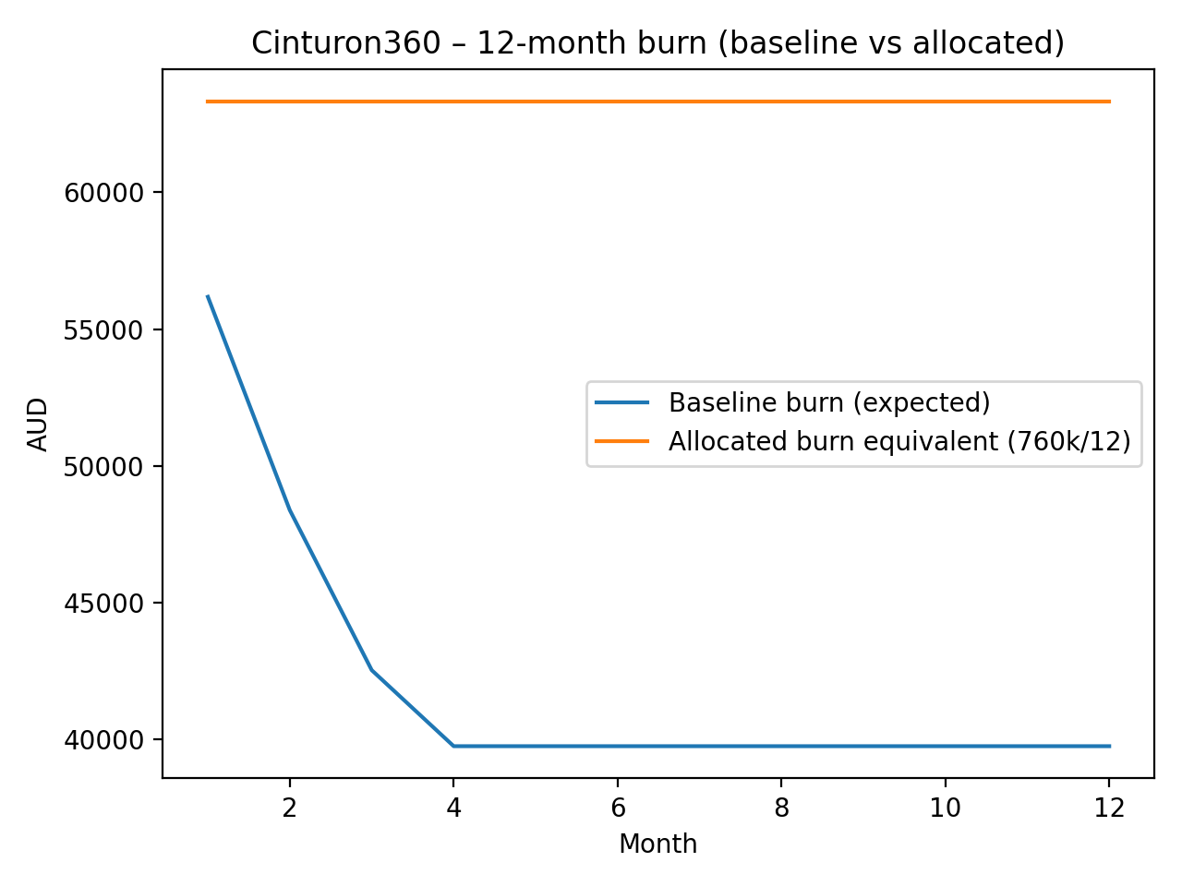

Cash Remaining Chart
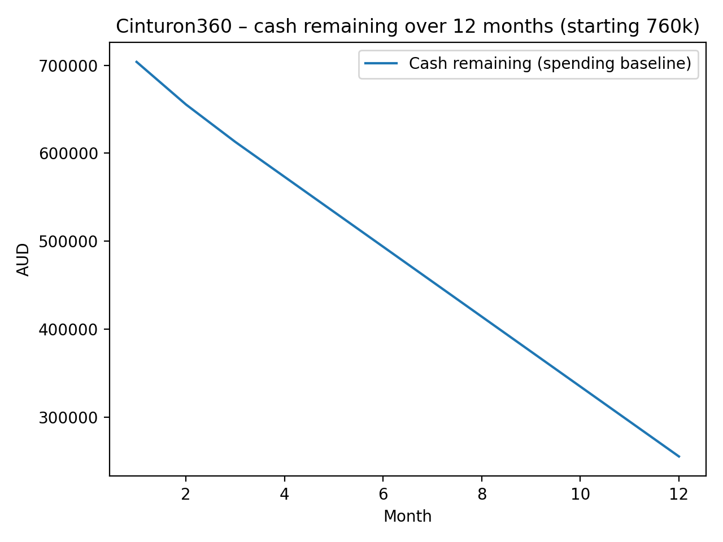

Investor-Relevant Section

Slide-ready “Use of Funds” paragraph
This funding allocation supports a structured 12-month engineering and platform execution plan to deliver the core foundations of Cinturon360 as a production-grade, multi-tenant travel management SaaS platform.

The allocation specifically funds:
- Core platform engineering, including architecture, backend services, frontend interfaces, and integration layers
- Enterprise-grade production infrastructure hosted in Azure, with dedicated DEV and UAT environments to ensure release safety and operational reliability
- Integration with travel distribution providers, billing systems, and operational third-party services required for commercial operation
- Engineering tooling, monitoring, observability, and deployment infrastructure necessary to operate the platform safely at scale
- Hardware and operational equipment to ensure uninterrupted developer productivity
- Legal, accounting, and compliance work required to support vendor onboarding, customer onboarding, and investor diligence
- A deliberately structured contingency reserve to prevent runway erosion caused by integration complexity, infrastructure scaling events, or hiring and retention risks

This funding plan is designed to maximize execution velocity while maintaining disciplined cost control and minimizing operational and delivery risk.

The allocation prioritizes platform stability, integration readiness, and predictable delivery timelines, ensuring the company can reach production-ready operational maturity within the planned funding window.

Why Azure for Production (Investor Framing)
Production infrastructure is hosted in Microsoft Azure to ensure maximum reliability, operational maturity, and enterprise readiness.

Azure is used specifically because it aligns with enterprise-grade operational requirements and investor expectations for platform reliability, security, and governance.

Key benefits:
- Enterprise-grade reliability and uptime posture
Azure provides mature infrastructure primitives designed for business-critical workloads. This includes managed compute, managed database services, integrated monitoring, and built-in redundancy capabilities. These services significantly reduce the operational risk associated with infrastructure failures.

- Strong security and governance model
Azure provides integrated identity and access management, secrets management, role-based access control, and audit logging. This allows strict enforcement of least-privilege access patterns and secure handling of credentials and sensitive data.

This is particularly important for travel-industry integrations, which often involve authenticated API access, sensitive booking data, and auditability requirements.

Managed services reduce operational overhead and failure modes
Azure’s managed services reduce the need for manual infrastructure management, patching, and maintenance. This allows the engineering team to focus on product delivery rather than infrastructure operations, improving capital efficiency.

Improved investor and enterprise customer confidence
Azure is widely used across enterprise environments, making security reviews, vendor onboarding, and investor technical diligence significantly easier. Hosting production infrastructure on Azure demonstrates operational maturity and reduces perceived platform risk.

Scalability without architectural disruption
Azure infrastructure can scale vertically and horizontally without requiring architectural redesign. This ensures that customer growth can be accommodated without platform instability or major engineering intervention.

This ensures production infrastructure can evolve alongside platform adoption without creating scaling bottlenecks or service interruptions.

Why Azure for UAT and Hetzner for DEV (Investor Framing)

Why Azure for UAT (User Acceptance Testing)
UAT infrastructure is hosted in Azure to ensure maximum parity with the production environment.

The primary purpose of UAT is to validate releases under conditions that closely match production behaviour. Hosting UAT in Azure ensures infrastructure, networking, identity handling, and service configuration are consistent with production.

Key benefits:

Production parity eliminates environment mismatch risk
Using the same cloud platform ensures that infrastructure behaviour –including networking, authentication, storage access, and managed services –is identical between UAT and production. This significantly reduces the risk of deployment-specific failures.

Release confidence and safer production deployments
All platform changes are validated in a production-equivalent environment before reaching customers. This ensures defects caused by environment differences are identified early and resolved before production release.

Integration reliability with external travel providers
Travel integrations often involve environment-specific authentication, rate limiting, and network behaviour. Hosting UAT in Azure ensures that connectivity, latency, and access patterns mirror production conditions, reducing integration-specific deployment risk.

Demonstrates operational discipline expected by investors
Maintaining a dedicated production-equivalent staging environment demonstrates a mature deployment and validation process, reducing perceived platform risk and improving investor confidence.

This significantly reduces the probability of production outages caused by environment-specific behaviour differences.

Why Hetzner for DEV (Development Environment)

Development infrastructure is hosted in Hetzner to optimize cost efficiency while maintaining sufficient performance for engineering productivity.

The development environment is inherently more volatile and experimental. It is frequently rebuilt, scaled, and modified during feature development and integration work.

Key benefits:

- Substantial cost efficiency without impacting delivery velocity
Hetzner provides high-performance infrastructure at significantly lower cost than enterprise cloud providers. This allows continuous engineering work without inflating infrastructure burn rate.

- Isolation of experimental work from production infrastructure
Development environments often involve incomplete features, experimental changes, and unstable configurations. Hosting DEV separately ensures experimental work cannot impact production or release validation environments.

- Improved capital efficiency and runway extension
By optimizing infrastructure costs in development environments, capital is preserved for critical functions such as engineering staffing, integration work, and production infrastructure.

This increases the effective runway without reducing engineering productivity.

- Operational flexibility for engineering iteration
Development environments can be rebuilt, scaled, or modified rapidly without affecting production infrastructure stability or cost.

This enables faster feature development and integration work.

Combined Infrastructure Strategy (Investor Summary)
The infrastructure model intentionally separates environments by operational purpose:
- Production (Azure): reliability, security, scalability, and operational maturity
- UAT (Azure): production-equivalent release validation and deployment safety
- DEV (Hetzner): cost-efficient engineering iteration and integration work

This hybrid approach balances enterprise reliability with aggressive cost optimization, ensuring both operational stability and capital efficiency.

How this reduces execution risk

This infrastructure and staffing strategy significantly reduces both technical and operational execution risk.

Key risk reductions include:
- Prevention of production-only failures
Maintaining separate DEV, UAT, and production environments ensures changes are validated before reaching production. This prevents failures caused by configuration differences, integration issues, or deployment errors.

- Improved incident detection and recovery capability
Integrated monitoring, logging, and alerting ensures issues are detected early and diagnosed quickly. This reduces mean-time-to-resolution (MTTR) and prevents prolonged outages.

- Reduced infrastructure scaling risk
Using managed infrastructure in Azure ensures the platform can scale without requiring major architectural changes, reducing the risk of scaling bottlenecks.

- Improved delivery predictability through structured engineering team design
The engineering team structure balances cost efficiency and delivery throughput while maintaining strong quality control through code review and structured development workflows.

- Explicit financial buffers prevent runway erosion caused by unexpected events
Contingency buffers protect against integration complexity, infrastructure scaling events, and hiring disruptions. This prevents the company from needing emergency fundraising due to predictable operational variability.

This significantly increases the probability of reaching operational maturity within the planned funding window.

Buffers mapped to known risk vectors

Each buffer category is deliberately structured to address specific, real-world operational risks.

- Integration buffer
Protects against variability in travel provider onboarding requirements, authentication mechanisms, testing environments, and operational constraints. Travel industry integrations frequently introduce unexpected complexity, and this buffer ensures integration timelines do not disrupt platform delivery.

- Infrastructure buffer
Protects against increases in database size, storage needs, logging retention, and traffic growth. Infrastructure scaling is a predictable consequence of platform growth, and this buffer ensures scalability does not create funding pressure.

- Staffing buffer
Protects against talent retention risk, hiring delays, or temporary staffing overlap during replacement or onboarding. This ensures continuity of delivery even if staffing events occur.

- Legal and compliance buffer
Protects against investor diligence requirements, vendor contract negotiations, privacy compliance work, and operational legal needs that arise as integrations mature.

- Operational contingency reserve
Protects against unknown unknowns, including integration delays, infrastructure anomalies, hiring disruptions, or accelerated growth scenarios requiring faster team expansion.

This structured buffer strategy ensures execution can continue without interruption under a wide range of real-world conditions.

Suggested investor KPIs

These metrics allow investors to track platform maturity, operational reliability, and capital efficiency.

Delivery KPIs
- Feature delivery throughput per sprint
- Lead time from development to production deployment
- Deployment frequency
- Defect rate and escaped defect rate

These indicate engineering productivity and delivery efficiency.

Reliability KPIs
- Platform uptime percentage
- API latency and error rates
- Incident frequency and severity
- Mean-time-to-resolution (MTTR)

These demonstrate platform stability and operational maturity.

Capital efficiency KPIs
- Infrastructure cost per active tenant
- Engineering delivery throughput relative to burn rate
- Integration cost per provider onboarded

These demonstrate efficient capital utilization and improving unit economics.

Milestone framing (Investor timeline guidance)

The 12-month plan is structured to progressively transition the platform from foundational build-out to operational readiness.

Months 1-2: Platform foundation
- Core platform architecture implementation
- DEV, UAT, and production environments established
- Continuous integration and deployment pipelines operational
- Initial core services implemented

Months 2-4: Core platform functionality
- Multi-tenant architecture fully operational
- Billing and platform policy enforcement implemented
- Platform operational tooling and monitoring stabilized

Months 3-6: External integration phase
- Travel provider integration infrastructure implemented
- End-to-end workflows operational and validated in UAT
- Integration reliability and monitoring hardened

Months 6-9: Platform hardening and operational maturity
- Performance optimization
- Monitoring and alerting refinement
- Operational readiness improvements
- Scalability validation

Months 9-12: Production readiness and onboarding readiness
- Platform stability confirmed under production workloads
- Integration workflows fully operational
- Infrastructure and deployment processes fully stabilized
- Platform ready for early customer onboarding and scaling

